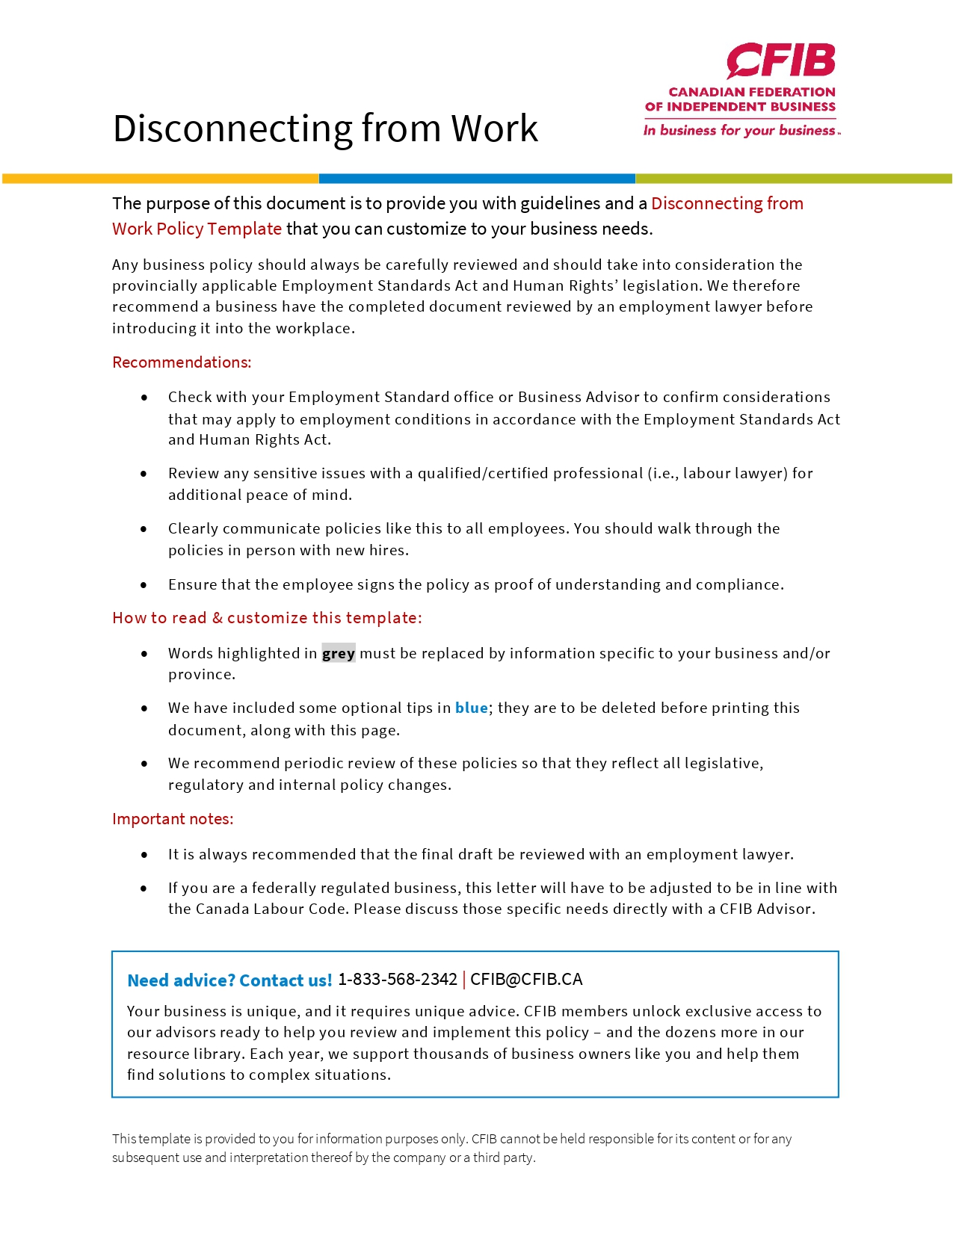
Guidance on the Disconnecting from Work Policy
In Ontario, all businesses with 25 or more employees on January 1 of any year, must put a Disconnecting from Work Policy in place before March 1 of that year. For 2022, the deadline for implementing a policy is June 1, 2022.
In all other provinces, there is no requirement to have a Disconnecting from Work policy; however, you may wish to implement one to help employees achieve a good work-life balance which can aid in retention.
Information for businesses in Ontario
How to count your employees
All employees are included in the count, regardless of whether they are full-time, part-time, casual, temporary, permanent. If they are employed by the business on January 1st, they must be counted. A business must look at the total number of employees they have (NOT per location) to determine if a policy is required.
Example: Joe owns 3 bakeries, one has 7 employees, and two have 12 employees each, for a total of 31 employees. Because the business has more than 25 employees, they must put in place a Disconnecting from Work policy for all employees.
When the number of employees changes throughout the year
If on January 1st you have fewer than 25 employees, you are not required to put a policy in place. Even if your number of employees increases to more than 25 over the course of the year, you are not required to put the policy in place. If on the following January 1st you have more than 25 employees, you will need to put the policy in place.
If you have more than 25 employees on January 1st, you must put a policy in place. Later in the year, even if the number of employees you have drops below 25, you must keep the policy in place. On the following January 1st, if you still have fewer than 25 employees, then you will not be required to have a policy in place for that year.
Giving a copy of the policy to your employees
All employees must be provided with a copy of the policy within 30 days of it being created, 30 days of it being changed (if an existing policy is updated), or 30 days of being hired in the case of new employees. The policy may be provided as a printed copy, as an attachment to an e-mail if the employee can print it, or as a link to an online document providing the employee has reasonable access to the document and is able to print it.
Updating the policy
You are not required to update the policy every year, however you should review the policy annually and make any necessary changes.
Record-keeping requirements
You must keep a copy of every Disconnecting from Work policy required by the Employment Standards Act for 3 years after the policy is no longer in effect.

This page can be discarded before giving the policy to your employees
DISCONNECTING FROM WORK POLICY
Name of Business recognizes the need for employees to disconnect entirely from work to maintain a healthy work-life balance.
Whether an employee is working traditional business hours, working remotely, or has a flexible working arrangement, this policy is in line with best practices to support an employee’s right to disconnect.
The term “disconnecting from work” is defined in the Employment Standards Act as: “not engaging in work-related communications, including emails, telephone calls, video calls or the sending or reviewing of other messages, so as to be free from the performance of work.” (Taken from the Ontario Employment Standards Act. This should be modified for businesses in other jurisdictions)
Name of business encourages employees to disconnect from all forms of work-related communications upon completion of their scheduled workday/shift, during lunch breaks, while on vacation, and during statutory holidays.
While you may receive emails outside of your regular hours of work, you are not expected to check or respond to them outside of your regular working hours.
We do acknowledge that there may be special circumstances where communication after working hours may be required; however, we are committed to ensuring that these circumstances are an exception and not a regular occurrence. These situations may include but are not limited to:
- Shortage in staffing levels/fill in for someone who is sick
- Sensitive deadlines
- Managing a crisis or unforeseeable circumstances
- Business or operational reasons requiring contacting an employee outside of working hours
If your manager requires you to work overtime, this policy will not come into effect until your overtime shift is completed.
Optional additional clauses:
Employees should activate their out-of-office notification and update their outgoing voicemail message when they are not scheduled to work, to communicate they will not be responding until the next scheduled workday.
Employees should add a footer to their e-mails indicating that they only respond to messages during their regular working hours and will reply when they are next scheduled to work.
If a matter is urgent, a insert method of communication will be used to get your immediate attention, with the subject line/opening line: insert verbiage to be used, i.e. urgent/shift change/emergency.
Communications regarding scheduling and calling in sick are exempt from this policy.

______________________________________ ___________________
Signature Date

AGREEMENT – NAME OF BUSINESS’S DISCONNECTING FROM WORK POLICY
We are pleased to welcome you to the name of business team.
This is a good opportunity to provide you with a copy of the Disconnecting from Work Policy, which will help you get off to a good start. The objective is to give you an overview of the business and the human resources practices of our company, and to ensure the efficiency of our operations and the harmony of our team.
All employees, whether seasoned or new, may occasionally need to consult the Disconnecting from Work Policy. This document is intended as an easy-to-use reference tool containing the answers to your main concerns. Should any of your questions remain unanswered, please feel free to contact name and telephone number.
All the name of business policies are evolving documents that may be adapted as appropriate to reflect cultural and organizational changes as well as the modifications that are constantly being made to government regulations. We name of business are committed to maintaining open and transparent communication with all employees and will provide updated policies (where applicable) in a timely manner.

ACKNOWLEDGEMENT OF HAVING READ AND UNDERSTOOD THE DISCONNECTING FROM WORK POLICY
I,________________________________, attest that I have read the Disconnecting from Work Policy and its various components, including the following:
- List any additional addendums (if applicable)

I acknowledge having received all the relevant information that I need in order to have a good understanding of the content and scope of this policy.

Employee – Print Name
Employee – Signature |  | Date
Employer – Print Name
Employer – Signature |  | Date

The original copy is given to the employee and the employer retains a photocopy for their files.

