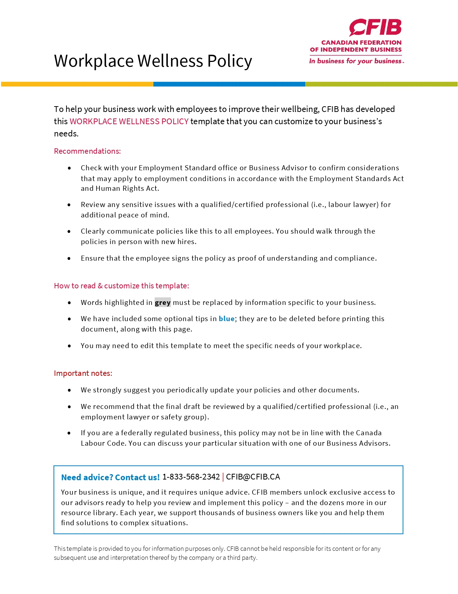
WORKPLACE WELLNESS POLICY

Wellness in employees is recognizing that they have a responsibility to take care of themselves emotionally, psychologically, and physically. Exercising, maintaining healthy relationships, and eliminating unhealthy behaviors all contribute to well-being.
There are many factors and conditions both in and out of the workplace that can negatively affect an employee’s well-being. Conditions such as mild depression, stress and severe anxiety may result in burnout and nervous breakdowns. Some employees may suffer with no physical side effects, while others may experience physical symptoms (e.g., increased blood pressure, lethargy, changes in eating habits.)
Employees may experience mental health issues for various reasons that an employer cannot control (e.g., hereditary, family conflicts, general health), but there are also work-related reasons for mental health problems which may include:

- Job insecurity
- Excessive pressure
- Work-life imbalance
- Lack of appreciation
- Hostile workplace conditions
- Unsatisfactory job or workload
- Unpleasant relationships with colleagues or managers

It’s important for employers and employees alike to be able to recognize these factors and work together to eliminate any barriers which may be getting in the way of an employee maintaining a state of well-being.

WORKPLACE WELLNESS POLICY FOR NAME OF BUSINESS

Name of business is committed to providing employees with a safe, healthy, and supportive environment in which to work. We recognize the importance of wellbeing and mental health within our organization and are committed to building and maintaining a workplace environment and culture where healthy lifestyle choices are valued and encouraged.
This policy applies to all employees of name of business
To every extent possible, name of business aims to recognize and address cases of workplace pressures that can affect the mental wellness of its employees.
We are committed to:
- Treating wellness as a priority
- Creating a workplace environment that cultivates open communication between management and employees
- Identifying issues proactively and resolving them
- Helping employees improve their wellness in the workplace
- Creating a pleasant workplace
Manager’s Responsibility
- Ensure all employees are made aware of this policy
- Actively support and contribute to the implementation of this policy
- Manage the implementation and ongoing maintenance of the policy
- Support and contribute to name of business’s aim of providing a safe, healthy, and supportive environment for all employees
- Be available to listen to employee concerns and work collaboratively to identify workplace wellness solutions
- Review and revise this policy as needed

Employee’s Responsibility
- Understand this policy and seek clarification from management where required
- Consider this policy while completing work-related duties and at any time while representing name of business
- Support fellow employees in their awareness of this policy
- Support and contribute to name of business’s aim of providing a safe, healthy, and supportive environment for all employees.

In cases where you feel your wellness in the workplace is being affected, name of business encourages you to speak confidentially with your manager about your situation.

Name of business commits to supporting you through the process of eliminating unhealthy stressors, ensuring that you are enjoying your work and have a balance between your job and personal life. Solutions may include but are not limited to:
- Workload assistance,
- Flexible work time / location, and
- Change in hours.

Each workplace wellness situation will be considered on a case-by-case basis and is at the discretion of management.

Name of business will ensure that:
- All employees receive a copy of this policy
- This policy is easily accessible by all members of the organisation
- Employees are empowered to actively contribute and provide feedback to this policy
- Employees are notified of all changes to this policy.

Date
Name of business reserves the right to amend this policy at any time

AGREEMENT – NAME OF BUSINESS’S WORKPLACE WELLNESS POLICY

We are pleased to welcome you to the name of business team.

This is a good opportunity to provide you with a copy of the Workplace Wellness Policy, which will help you get off to a good start. The objective is to give you an overview of the business and the human resources practices of our company, and to ensure the efficiency of our operations and the harmony of our team.

All employees, whether seasoned or new, may occasionally need to consult the Wellness Policy. This document is intended as an easy-to-use reference tool containing the answers to your main concerns. Should any of your questions remain unanswered, please feel free to contact name and telephone number.

All the name of business policies are evolving documents that may be adapted as appropriate to reflect cultural and organizational changes as well as the modifications that are constantly being made to government regulations. We name of business are committed to maintaining open and transparent communication with all employees and will provide updated policies (where applicable) in a timely manner.

ACKNOWLEDGEMENT OF HAVING READ AND UNDERSTOOD THE WORKPLACE WELLNESS POLICY

I, _____________________________, attest that I have read the Workplace Wellness Policy and its various components, including the following:

- List any additional addendums (if applicable)

I acknowledge having received all the relevant information that I need in order to have a good understanding of the content and scope of this policy.

Employee - Print Name

Employee - Signature Date

Employer’s Signature Date

The original copy is given to the employee and the employer retains a photocopy for their files.

