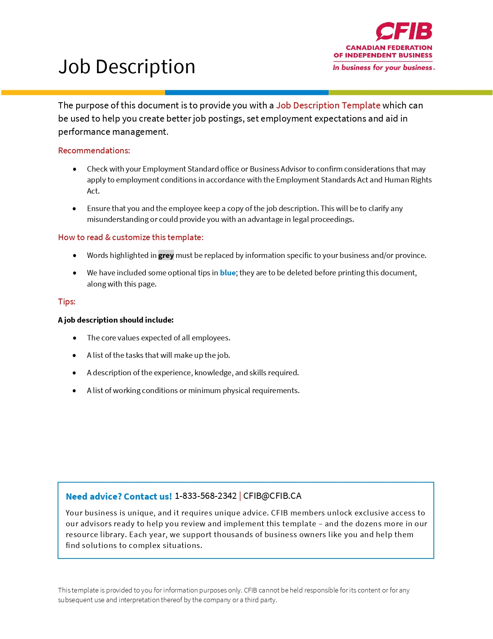
NAME OF BUSINESS Job Description

The following set of guidelines will help you create a job description for positions within your company. Note that the examples given are random and do not represent the requirements for any particular job.

Name of business and logo

JOB DESCRIPTION

Job Title:
Department:
Reports to: Name and position of the person to whom the employee will report
Date:

JOB PURPOSE
Write a one-sentence description of this position’s purpose within your organization.

Example:
As a member of our customer service team, the receptionist is responsible for greeting clients at the reception desk and answering incoming calls in a timely and courteous manner.

RESPONSIBILITIES
List the key responsibilities of this position using action verbs such as “develop”, “provide”, “maintain” and “prepare”. Be precise and clear.

Examples:
- Assist in coordinating monthly special events by developing a project management plan and a detailed budget
- Prepare accurate weekly sales reports by entering data into spreadsheets
- Conduct interviews and make recommendations on employee selection

Note: It is important to include a statement at the end of the list of responsibilities that provides flexibility in changing and updating positions. For instance, “Assist periodically with special projects as required”.

REQUIRED KNOWLEDGE, SKILLS AND EXPERIENCE
List all requirements for the position with regards to education, skills, experience, specific licenses and certifications.

Examples:
- Office Administration Diploma
- Proficiency in Microsoft Word, Excel and PowerPoint
- WHMIS certification
- Excellent verbal and written communication skills to provide a high level of response to customer inquiries.

WORKING CONDITIONS & PHYSICAL REQUIREMENTS
Describe overall working conditions such as hours of work, as well as any physical demands that must be met by an employee to successfully perform the essential functions of the job.

Examples:
- The hours for this position are from 9:00 a.m. to 5:00 p.m. from Monday to Friday. Some overtime may be required.
- This is a home-based job requiring extended computer use.
- Personal protective equipment must be worn at all times.
- This job requires frequent heavy lifting.

CONFIDENTIALITY AND DISCRETION
Job descriptions should outline the terms and conditions that prohibit the employee from disclosing company confidential and proprietary information.

Example:
The incumbent must maintain the confidentiality of all company and customer information and must not discuss such matters outside of Name of business. Tact and discretion must be used in all dealings with all customers and potential customers to maintain a positive image of Name of business.

