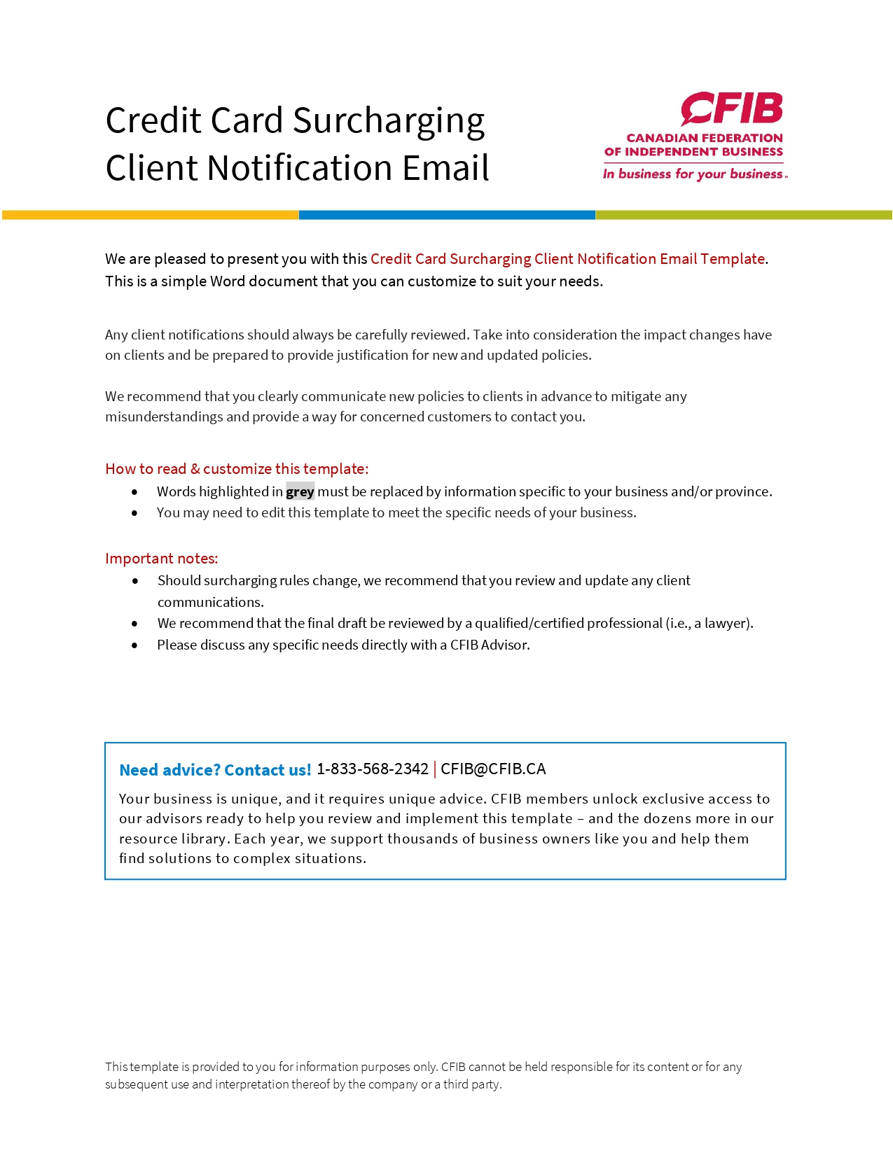
Dear Customer,
Thank you for supporting our small business.
To manage the increasing costs of credit card processing fees, we will be implementing a surcharge of X% on all credit card transactions beginning October 6, 2022.
There will be no surcharge on purchases paid by debit card or with cash.
Each time a customer pays by credit card, the credit card company charges the business a percentage of the transaction amount as a processing fee. This can range from 1.5% to 2.5% of the transaction amount and depend on the type of card used. Generally, the more rewards your card offers (i.e., travel points, cash back, insurance), the more it costs the business to process your transaction.
Learn more about Surcharging in Canada from the Canadian Federation of Independent Business (CFIB) who pushes forward small business issues on our behalf.
We appreciate your continued support and thank you for your understanding,
Name of business

