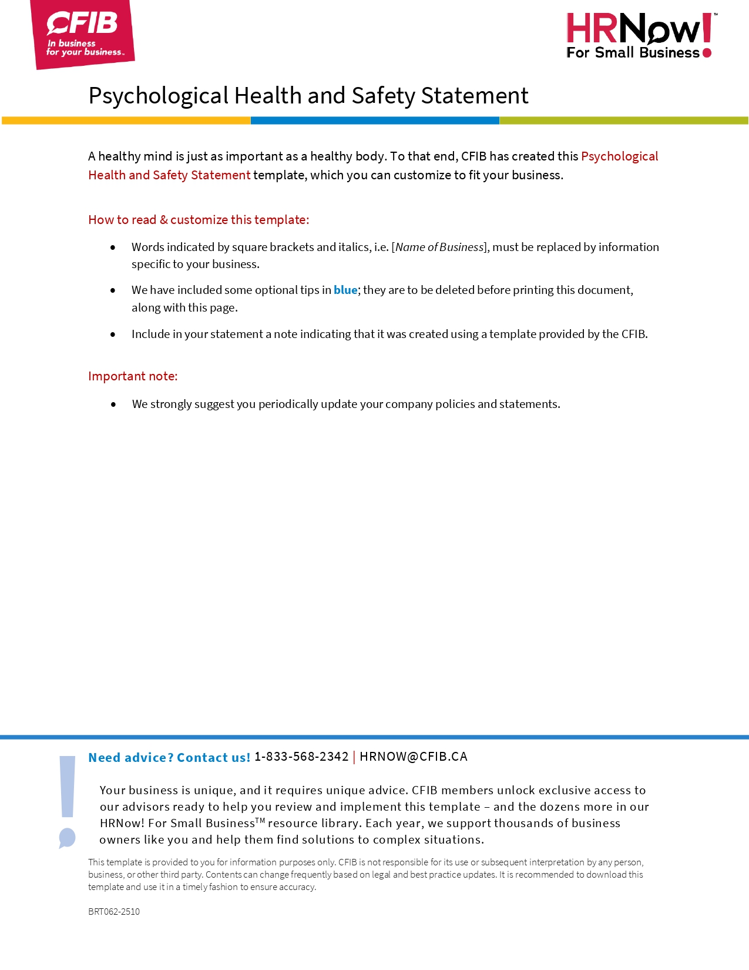
PSYCHOLOGICAL HEALTH AND SAFETY STATEMENT

At [name of business], we believe that a healthy mind is just as important as a healthy body. We’re committed to creating a workplace where everyone feels safe, respected, and supported—both emotionally and mentally.
We commit to:
- Making mental health a priority by encouraging open conversations and reducing stigma.
- Identifying and preventing situations that cause stress such as unclear expectations, workplace conflict, and burnout.
- Supporting each other—whether someone’s going through a tough time or just needs a little extra flexibility.
- Listening and learning from our team to keep improving how we support mental wellbeing.
Management will lead with empathy, make space for mental health conversations, and ensure resources are available.
Workers are encouraged to look out for one another, speak up if something’s not right, and take care of their own wellbeing.
[Name of business] understands that mental health is personal. All conversations will be treated with care and confidentiality. Discrimination and/or judgment around mental health will not be tolerated.
In situations where you feel the behaviour or speech of an individual goes against this statement, [name of business] encourages you to speak with [owner/manager] about your concerns.

________________________________________
Name

________________________________________ _____________________
Signature Date

It is best practice to give a copy to your employees for their files.

